# Practical No. 6. Handling different types of alerts in Selenium Date:

**Aim:**

To learn how to handle various types of alerts in Selenium.

# Theory:

An Alert in Selenium is a small message box which appears on screen to give the user some information or notification. It notifies the user with some specific information or error, asks for permission to perform certain tasks and it also provides warning messages as well. Here are few alerts in Selenium:

# Simple Alert

The simple alert class in Selenium displays some information or warning on the screen.

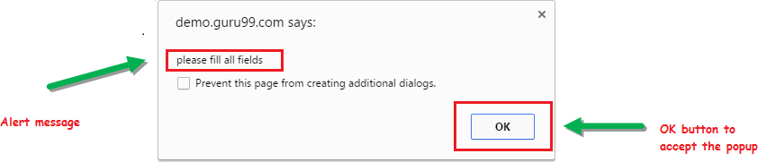

# Prompt Alert.

This Prompt Alert asks some input from the user and Selenium webdriver can enter the text using sendkeys(” input…. “).

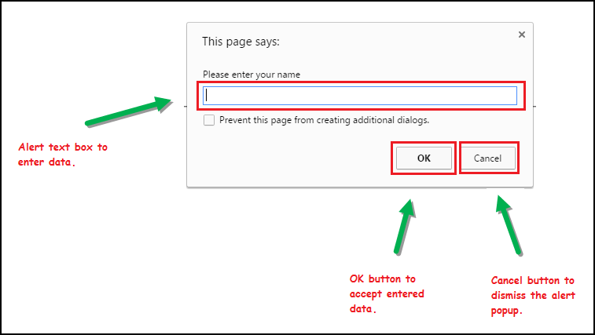

# Confirmation Alert.

This confirmation alert asks permission to do some type of operation.

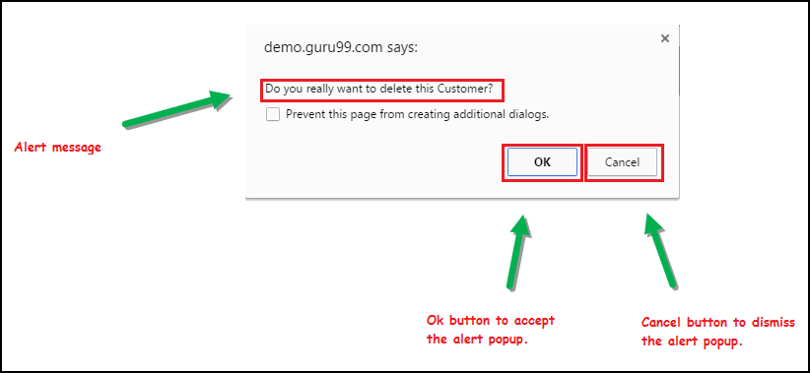

Apart from switching between windows and frames, you may have to handle various modal dialogs in a web application. For this, WebDriver provides an API to handle alert dialogs. The API for that is as follows:

# Alert alert()

The preceding method will switch to the currently active modal dialog on the web page. This returns an Alert instance where appropriate actions can be taken on that dialog. If there is no dialog currently present, and you invoke this API, it throws back a **NoAlertPresentException.**

The Alert interface contains a number of APIs to execute different actions. The following list discusses them one after the other:

# void accept():

This is equivalent to the OK button action on the dialog. The corresponding OK button actions are invoked when the accept() action is taken on a dialog.

# void dismiss():

This is equivalent to clicking on the CANCEL action button.

# java.lang.String getText():

This will return the text that appears on the dialog. This can be used if you want to evaluate the text on the modal dialog.

# void sendKeys(java.lang.String keysToSend):

This will allow the developer to type in some text into the alert if the alert has some provision

for it.

## Implementation

* 1. **Write a selenium script to handle alert on** [**http://only-testing-blog.blogspot.com/2013/09/test.html**](http://only-testing-blog.blogspot.com/2013/09/test.html)

package first_practical;

import java.util.Iterator;

import java.util.Set;

import org.openqa.selenium.Alert;

import org.openqa.selenium.By;

import org.openqa.selenium.WebDriver;

import org.openqa.selenium.WebElement;

import org.openqa.selenium.chrome.ChromeDriver;

public class KeyInteractions {

public static void main(String[] args) throws InterruptedException {

// **TODO** Auto-generated method stub

System.*setProperty*("webdriver.chrome.driver", "C:\\Users\\parun\\Desktop\\FAMT\\Cyber Security\\driver\\chromedriver.exe");

WebDriver driver=new ChromeDriver();

driver.get("http://only-testing-blog.blogspot.com/2013/09/test.html");

WebElement alertBtn=driver.findElement(By.*cssSelector*("input[value='Show Me Alert']"));

alertBtn.click();

Alert simpleAlert=driver.switchTo().alert();

Thread.*sleep*(3000);

String alertText=simpleAlert.getText();

System.***out***.println("Alert Text is: "+alertText);

simpleAlert.accept();

Thread.*sleep*(3000);

WebElement confirmAlertBtn=driver.findElement(By.*cssSelector*("button[onclick='myFunction()']"));

confirmAlertBtn.click();

Alert ConfirmAlert=driver.switchTo().alert();

Thread.*sleep*(3000);

String confirmalertText=ConfirmAlert.getText();

System.***out***.println("Confirmation Alert Text is: "+confirmalertText);

simpleAlert.accept();

}

}

**Output:**

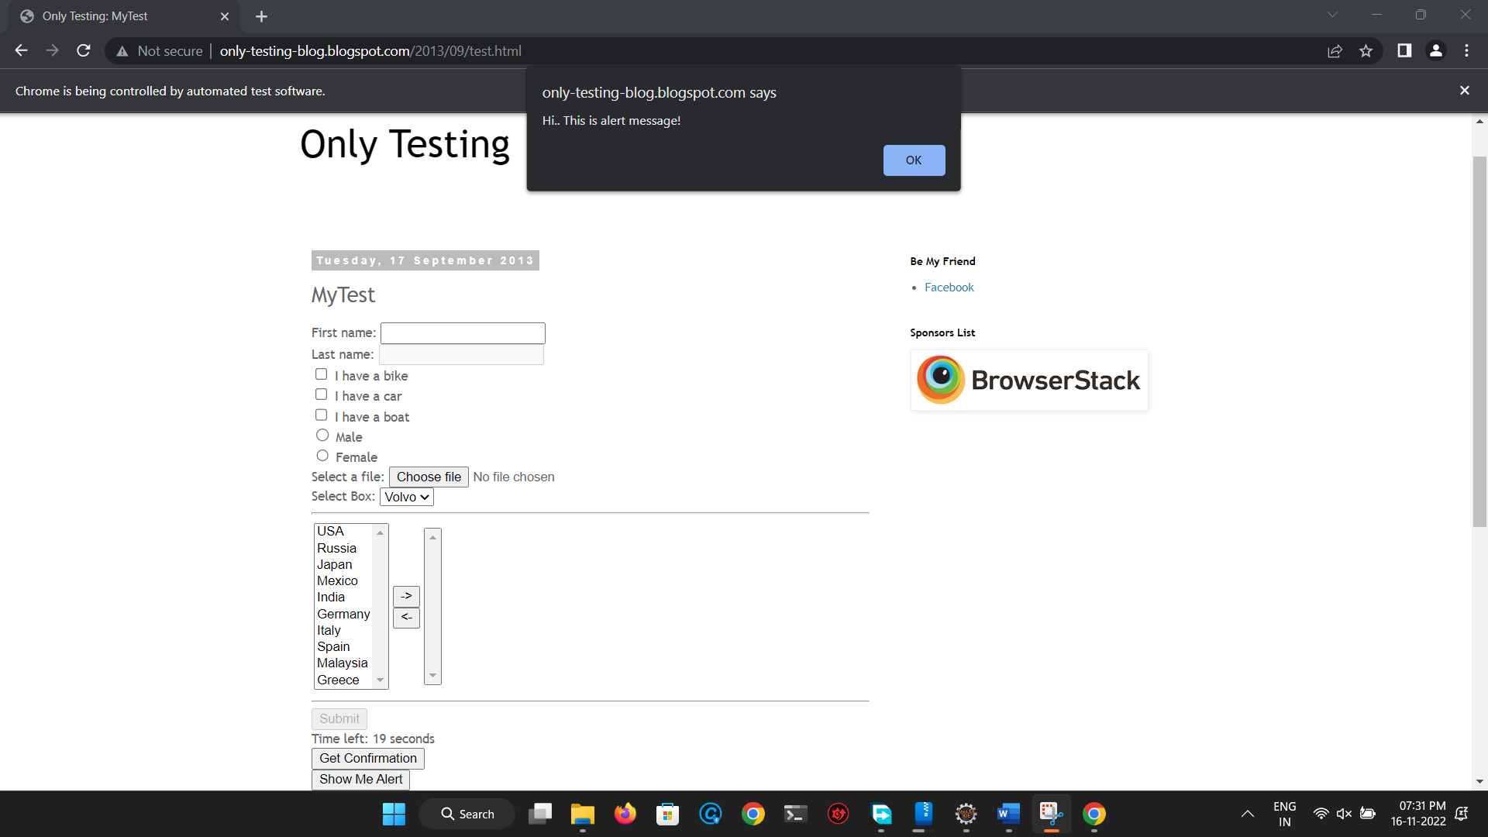

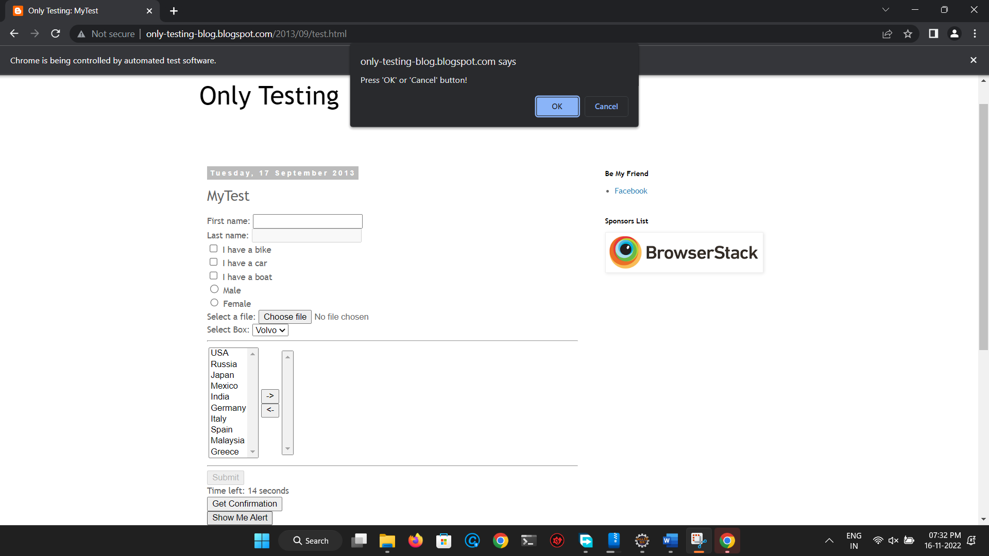

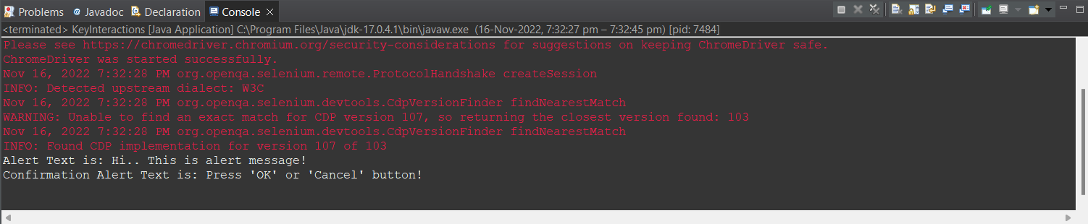

* 1. **Write a selenium script to handle alerts on** [**https://demoqa.com/alerts**](https://demoqa.com/alerts)

package first_practical;

import java.util.Iterator;

import java.util.Set;

import org.openqa.selenium.Alert;

import org.openqa.selenium.By;

import org.openqa.selenium.WebDriver;

import org.openqa.selenium.WebElement;

import org.openqa.selenium.chrome.ChromeDriver;

public class KeyInteractions {

public static void main(String[] args) throws InterruptedException {

// **TODO** Auto-generated method stub

System.*setProperty*("webdriver.chrome.driver", "C:\\Users\\parun\\Desktop\\FAMT\\Cyber Security\\driver\\chromedriver.exe");

WebDriver driver=new ChromeDriver();

driver.get("https://demoqa.com/alerts");

WebElement btn1=driver.findElement(By.*id*("alertButton"));

btn1.click();

Alert alert1=driver.switchTo().alert();

Thread.*sleep*(3000);

String alert1Text=alert1.getText();

System.***out***.println("Alert 1 Text is: "+alert1Text);

alert1.accept();

Thread.*sleep*(3000);

WebElement btn2=driver.findElement(By.*id*("timerAlertButton"));

btn2.click();

Thread.*sleep*(7000);

Alert alert2=driver.switchTo().alert();

Thread.*sleep*(3000);

String alert2Text=alert2.getText();

System.***out***.println("Alert 2 Text is: "+alert2Text);

alert2.accept();

Thread.*sleep*(3000);

WebElement btn3=driver.findElement(By.*id*("confirmButton"));

btn3.click();

Alert alert3=driver.switchTo().alert();

Thread.*sleep*(3000);

String alert3Text=alert2.getText();

System.***out***.println("Alert 3 Text is: "+alert3Text);

alert3.accept();

Thread.*sleep*(3000);

WebElement btn4=driver.findElement(By.*id*("promtButton"));

btn4.click();

Alert alert4=driver.switchTo().alert();

Thread.*sleep*(3000);

alert4.sendKeys("26");

Thread.*sleep*(3000);

alert3.accept();

}

}

**Output:**

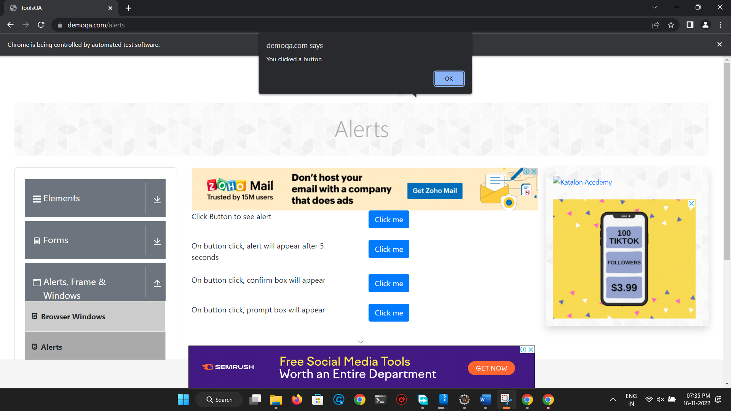

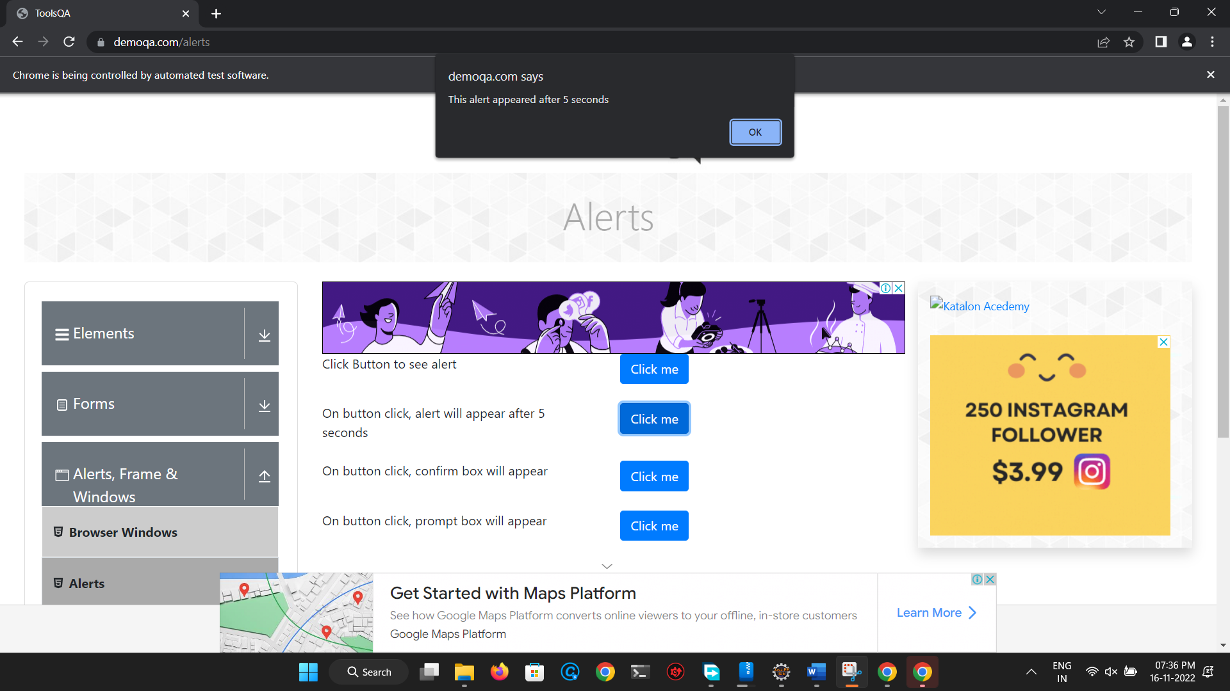

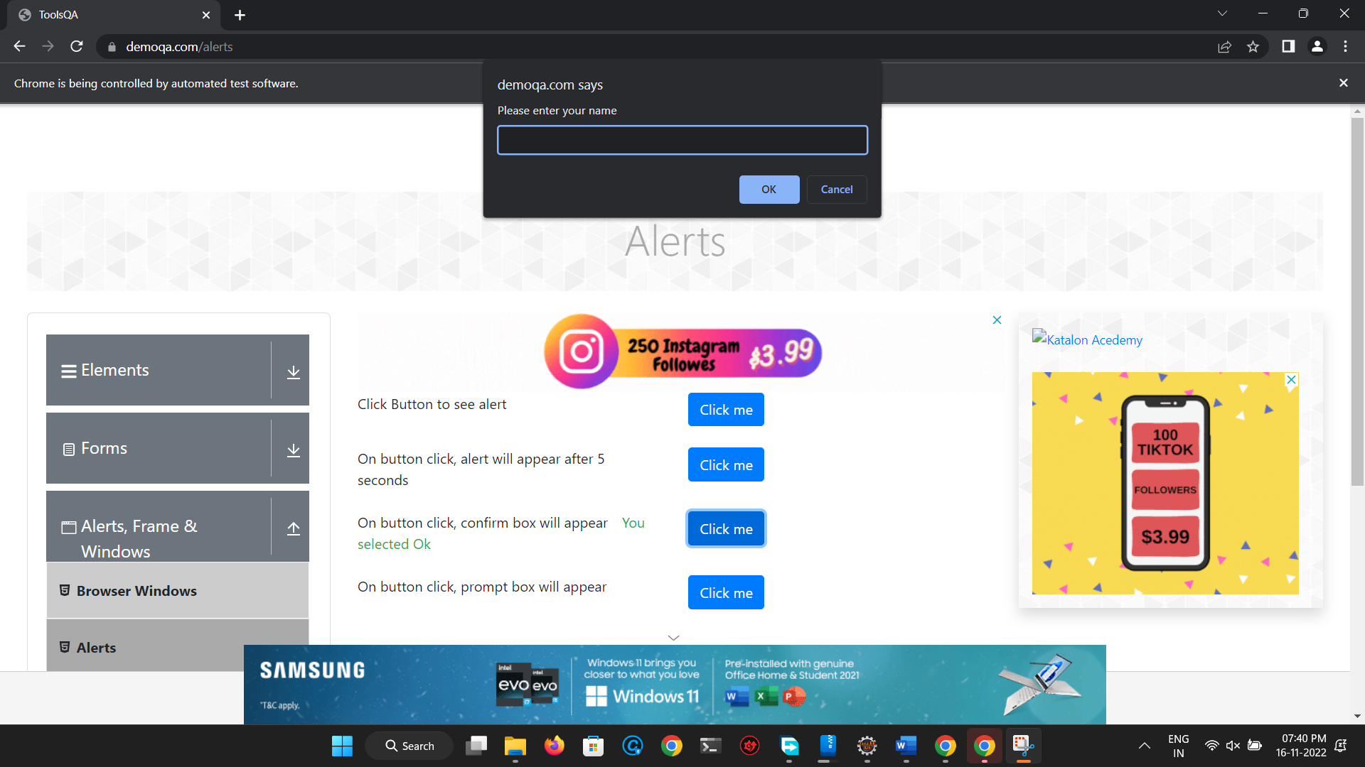

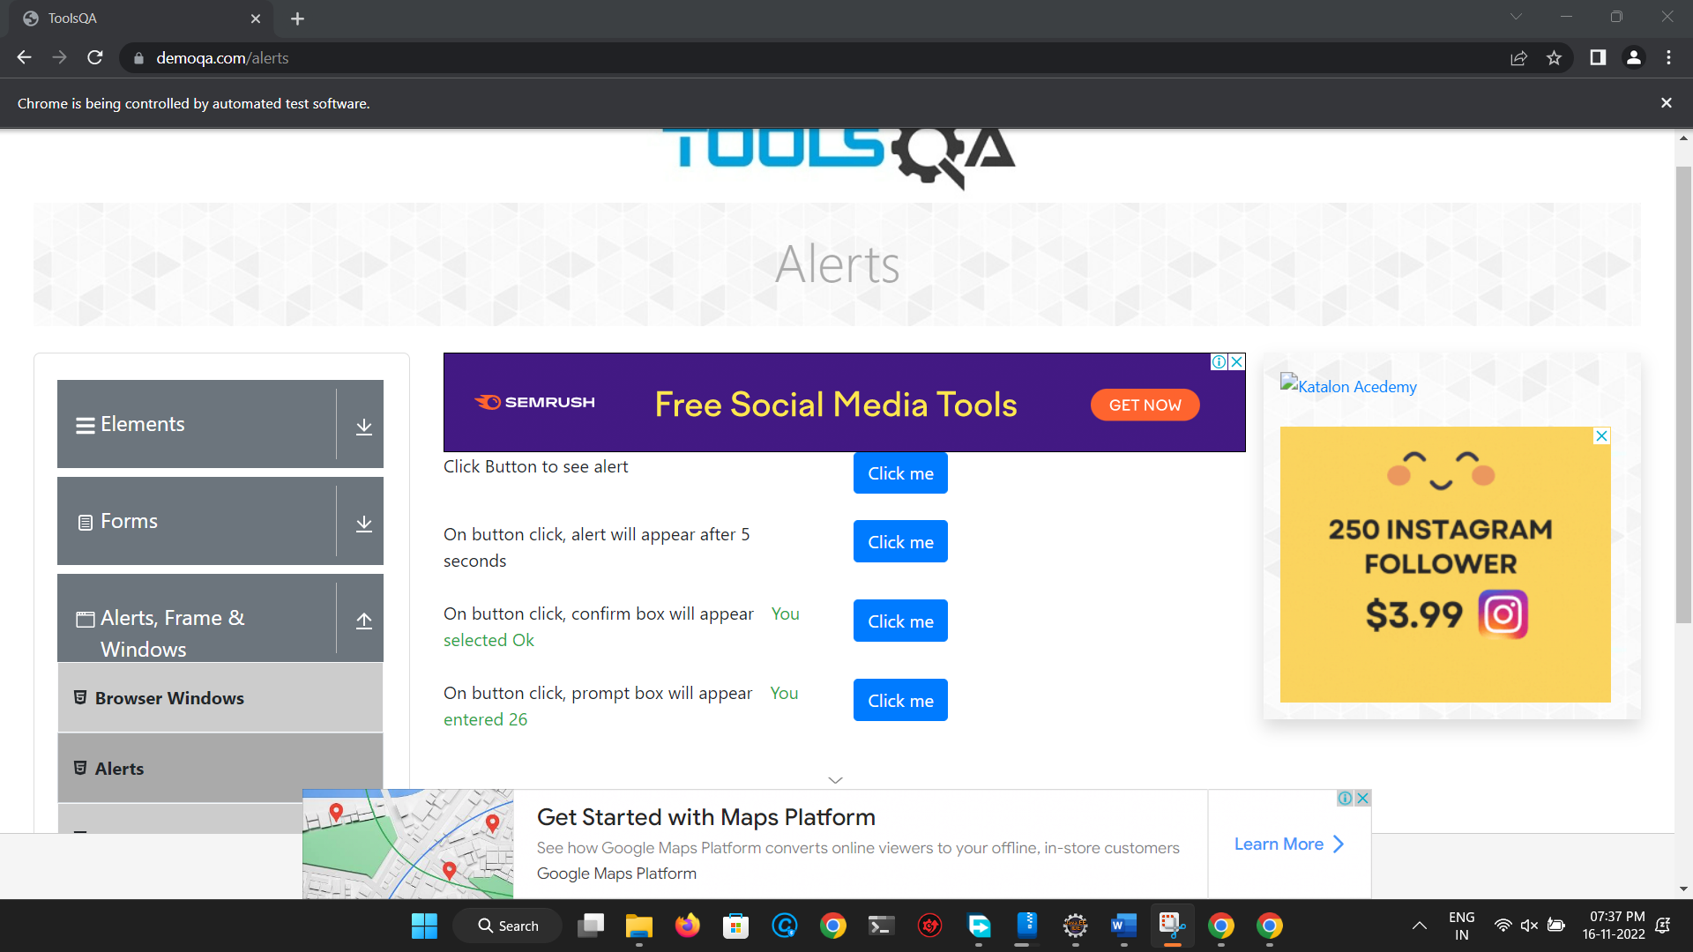

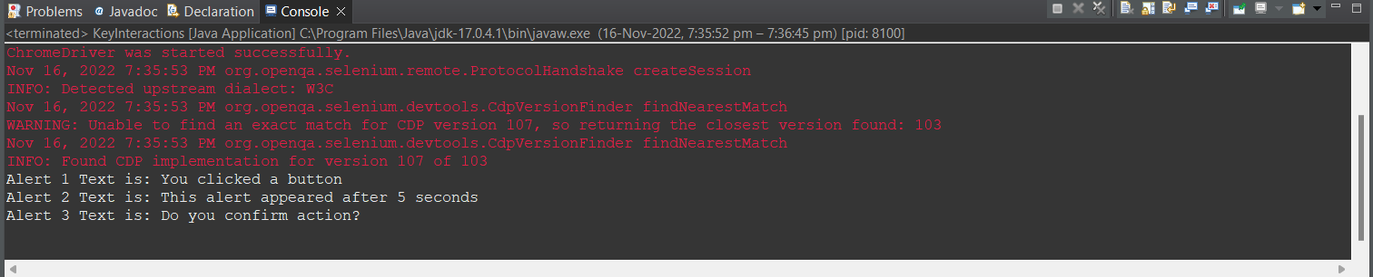

* 1. **Write a selenium script to handle alert on** [**http://demo.guru99.com/test/simple_context_menu.html**](http://demo.guru99.com/test/simple_context_menu.html)

**package first_practical;**

**import java.util.Iterator;**

**import java.util.Set;**

**import org.openqa.selenium.Alert;**

**import org.openqa.selenium.By;**

**import org.openqa.selenium.WebDriver;**

**import org.openqa.selenium.WebElement;**

**import org.openqa.selenium.chrome.ChromeDriver;**

**import org.openqa.selenium.interactions.Actions;**

**public class KeyInteractions {**

**public static void main(String[] args) throws InterruptedException {**

**// TODO Auto-generated method stub**

**System.setProperty("webdriver.chrome.driver", "C:\\Users\\parun\\Desktop\\FAMT\\Cyber Security\\driver\\chromedriver.exe");**

**WebDriver driver=new ChromeDriver();**

**driver.get("https://demo.guru99.com/test/simple_context_menu.html");**

**Actions action = new Actions(driver);**

**WebElement link =driver.findElement(By.xpath("//button[text()='Double-Click Me To See Alert']"));**

**action.doubleClick(link).perform();**

**//Switch to the alert box and click on OK button**

**Alert alert = driver.switchTo().alert();**

**System.out.println("Alert Text: " +alert.getText());**

**Thread.sleep(3000);**

**alert.accept();**

**}**

**}**

Output:

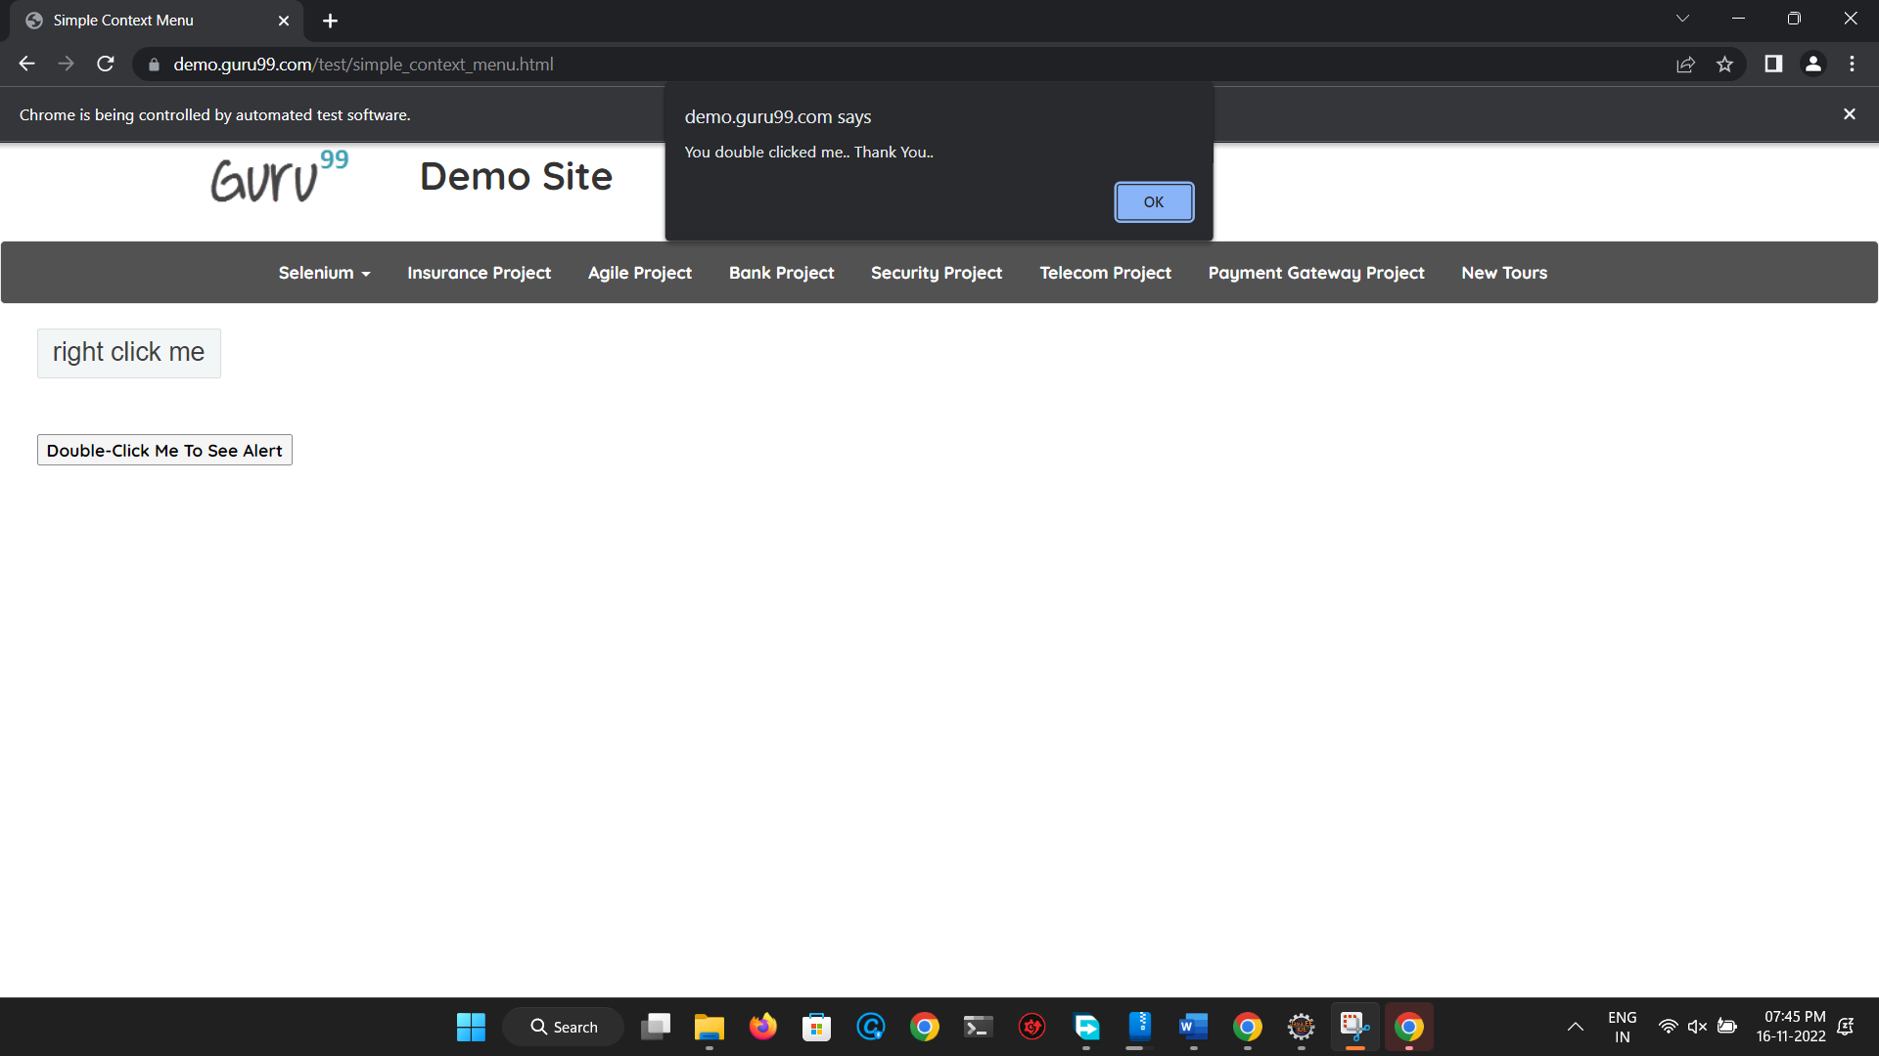

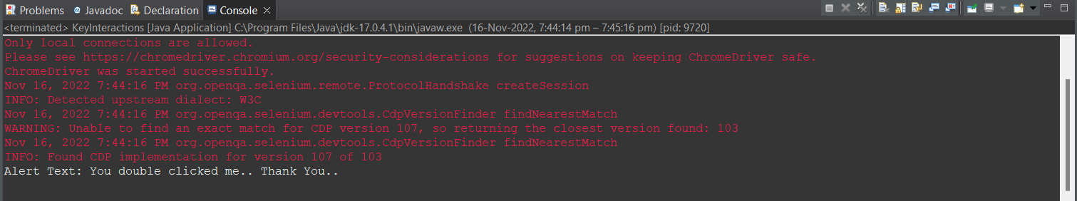

* 1. **Open “train_reservation.html” page and handle the alerts on that page.**

package first_practical;

import java.util.Iterator;

import java.util.Set;

import org.openqa.selenium.Alert;

import org.openqa.selenium.By;

import org.openqa.selenium.WebDriver;

import org.openqa.selenium.WebElement;

import org.openqa.selenium.chrome.ChromeDriver;

import org.openqa.selenium.interactions.Actions;

public class KeyInteractions {

public static void main(String[] args) throws InterruptedException {

// TODO Auto-generated method stub

System.setProperty("webdriver.chrome.driver", "C:\\Users\\parun\\Desktop\\FAMT\\Cyber Security\\driver\\chromedriver.exe");

WebDriver driver=new ChromeDriver();

driver.get("file:///H:/imp/Flight_Reservation/flight_reservation.html");

WebElement train_link=driver.findElement(By.linkText("Trains"));

train_link.click();

//Handling simple alert

Alert simpleAlert=driver.switchTo().alert();

Thread.sleep(5000);

String alertText=simpleAlert.getText();

System.out.println("Alert Text is: "+alertText);

simpleAlert.accept();

Thread.sleep(5000);

//Handling Prompt Alert

WebElement confirmButton=driver.findElement(By.cssSelector("input[value='Confirm Details']"));

confirmButton.click();

Alert promptAlert=driver.switchTo().alert();

promptAlert.sendKeys("3");

Thread.sleep(3000);

promptAlert.accept();

Thread.sleep(4000);

//Handling Confirmation Alert

WebElement bookButton=driver.findElement(By.cssSelector("input[value='Book Tickets']"));

bookButton.click();

Alert confirmAlert=driver.switchTo().alert();

System.out.println("Confirmation Alert Text is: "+confirmAlert.getText());

Thread.sleep(3000);

confirmAlert.accept();

}

}

Output:

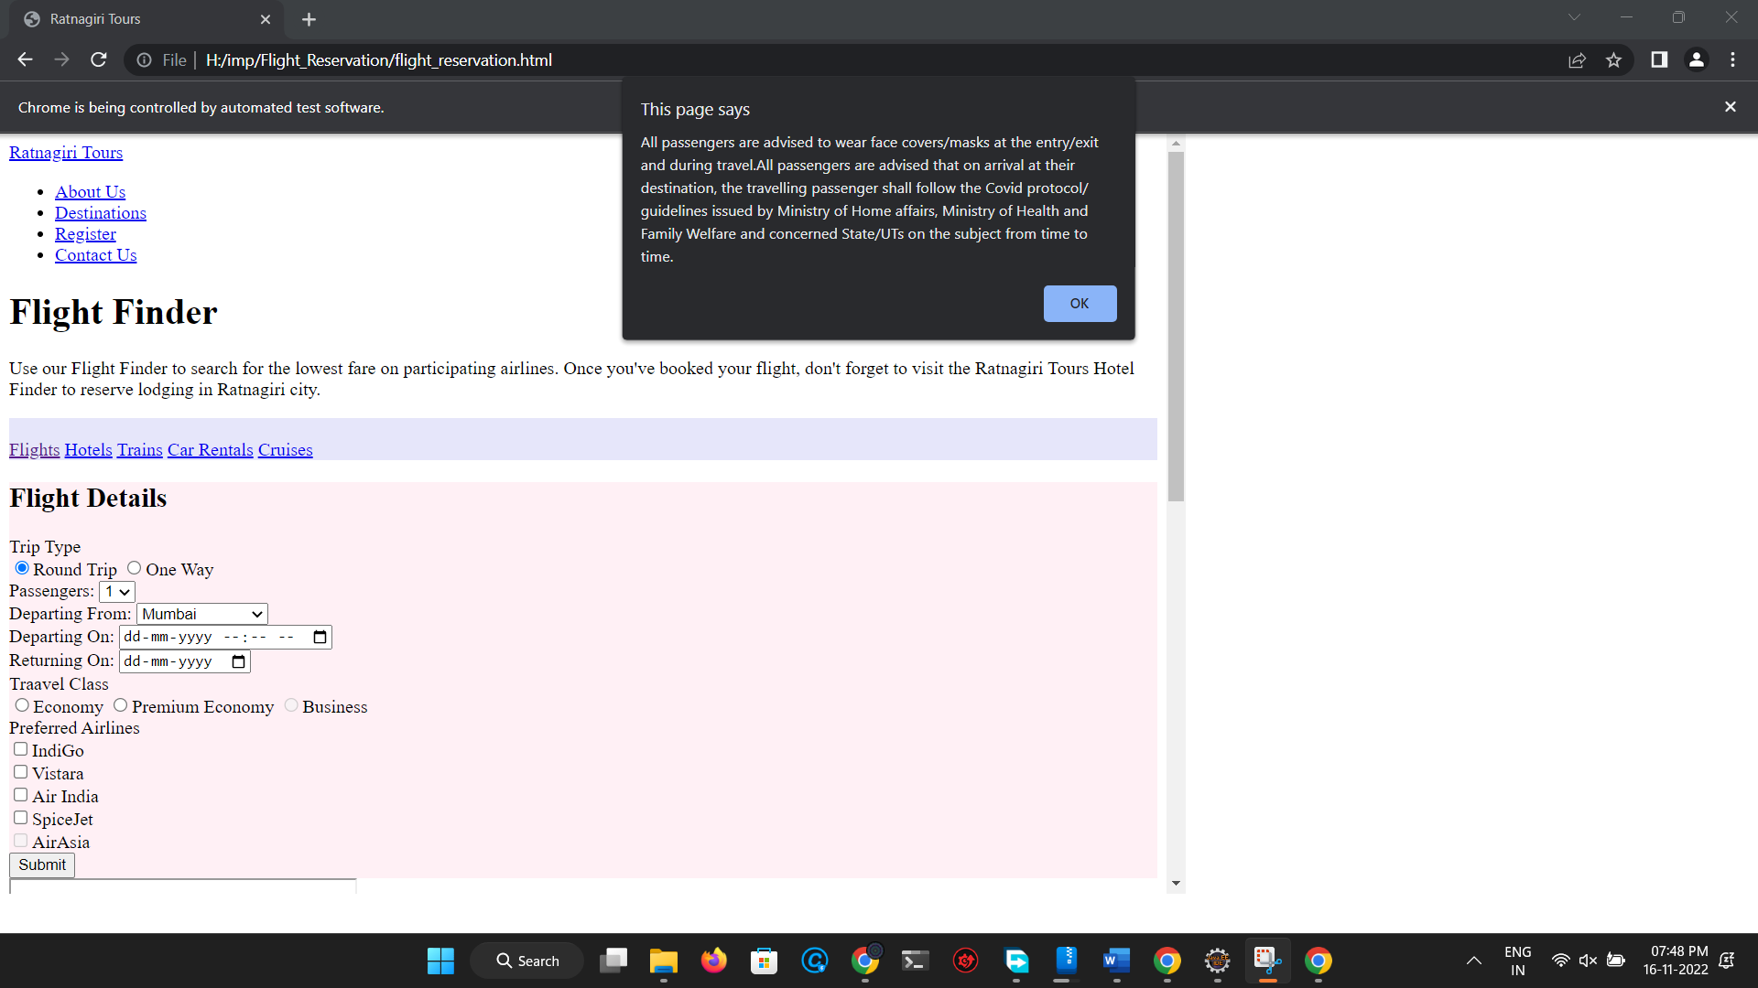

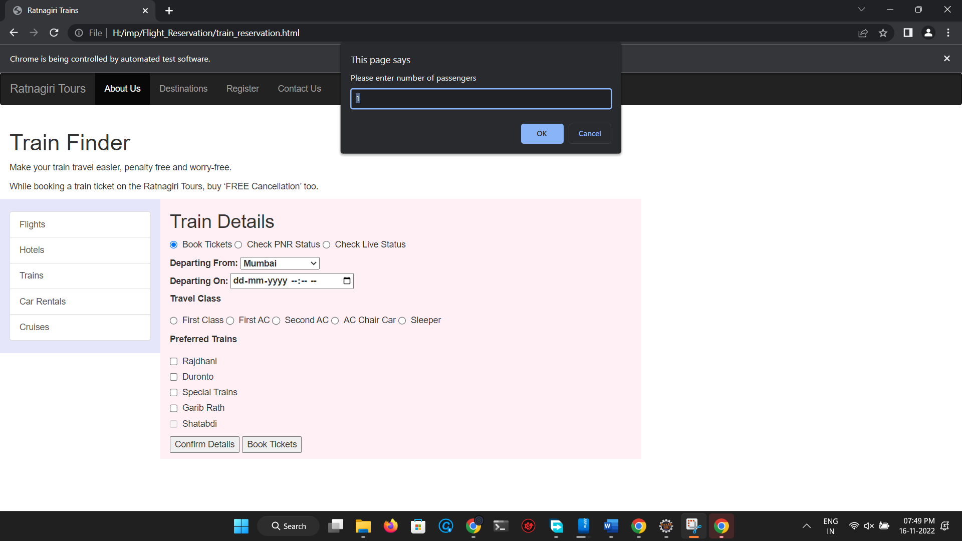

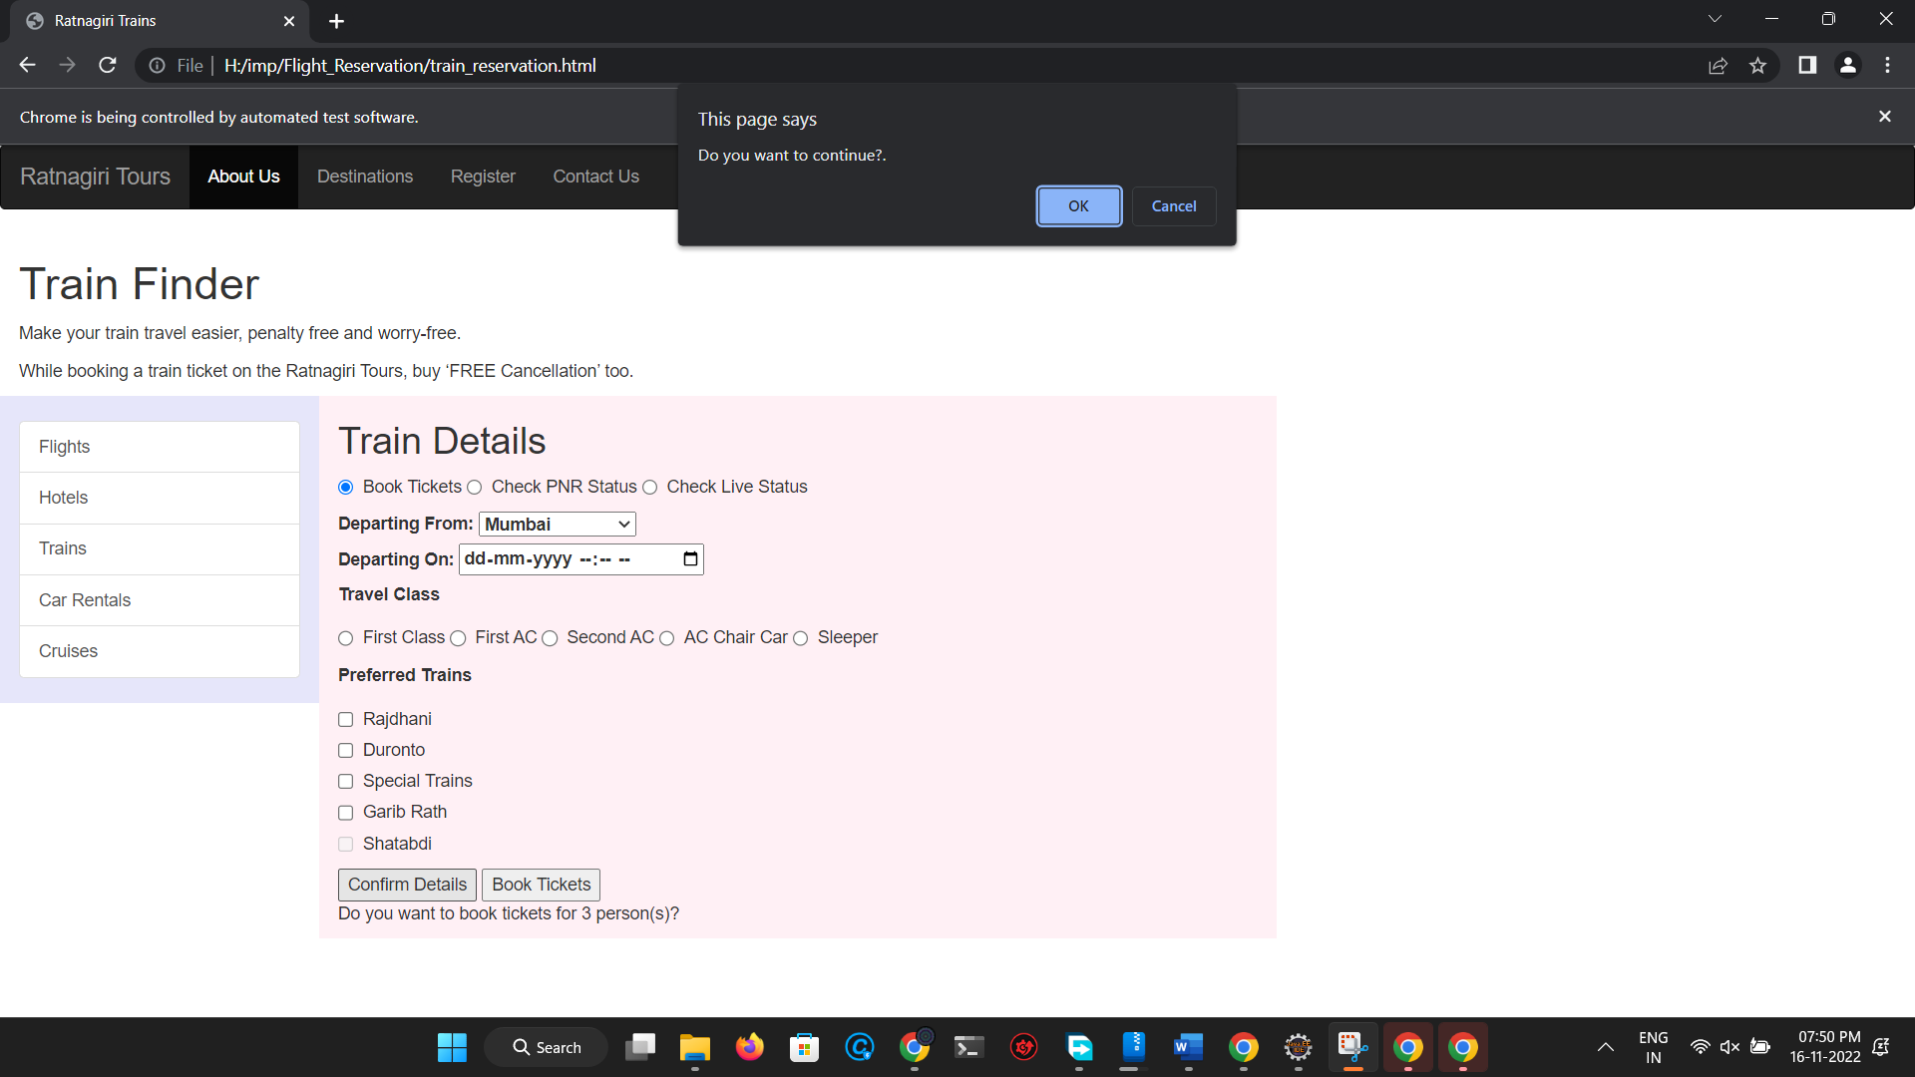

**Conclusion:** Learnt to handle all types of alerts in Selenium

## After performing this Practical/lab, students are expected to answer following questions

* 1. What are different types of alert()?
  2. Which method is used to cancel or close alert window?